

UAT Plan and QA result for __________________________

|  |  |
| --- | --- |
| Project/TaskTitle: | BRD95367 & We would like to keep Agreement Date on Ax. |
| Author: |  |
| Review: |  |
| Date: | 21-16 Dec 2011 |
| Reference: | BRD95367 |

|  |  |  |  |
| --- | --- | --- | --- |
| Distribution for Sign Off: | Sign Off Received: | Distribution for Sign Off: | Sign Off Received: |
|  |  | Semra Kapullu |  |
|  |  |  |  |
|  |  |  |  |

# 

# User Acceptance Testing Test Carried Out by: Date: Time:

|  |  |  |  |  |  |  |
| --- | --- | --- | --- | --- | --- | --- |
| No | Case /Scenario | Input data | Expected results | Actual results | Action to take/required | Remarks |
| 1) | Create new order using agreement date  Agrement date on appointment review screen? | Enter valid date | System shows agreement date at appointment review screen. | Correct | Passed | PASS |
| 2) | Agrement date on customer screen? |  | System shows agreement date at customer screen. | Correct | Passed | PASS |

AXAPTA RESULTS

1-While creating new appointment, I can entered Agreement date at new appointment screen at QA.

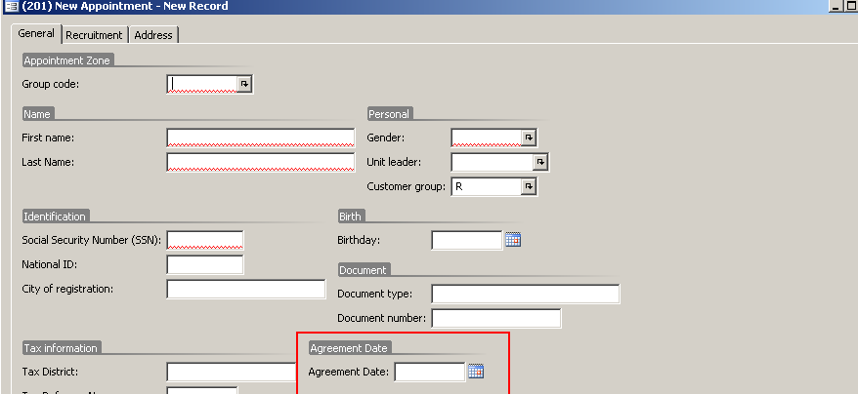

This field is shown at appointment review screen.

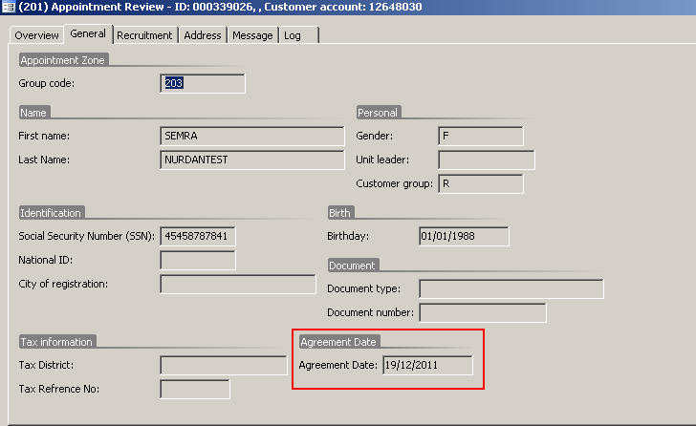

This field is shown at customer screen.

